**RV Storage Application**

Back Office Maintenance Notes - Thomas Uyemura

July 17th, 2015

a) The RV Storage Application consists of two screens and a number of Function Buttons. The Two Screens are shown below. The latest version is dated July 17th, 2015. This version date is shown on the top of the window.

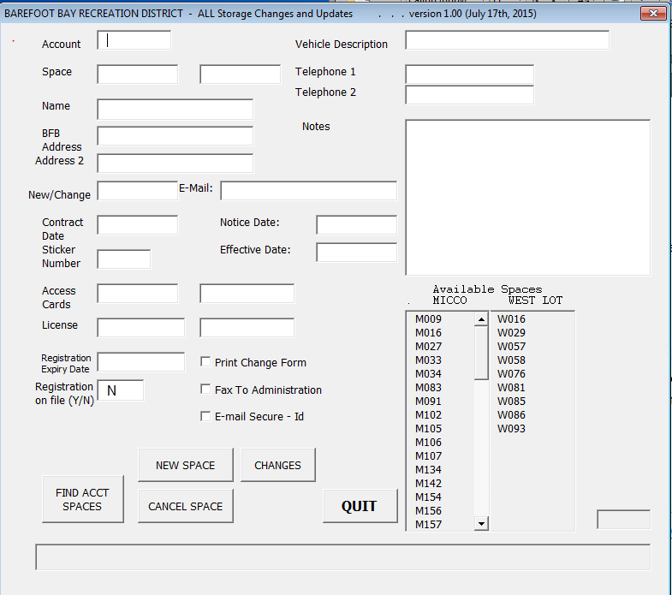

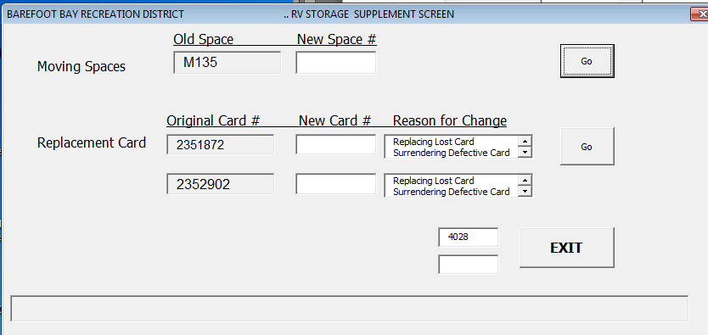

b) All screens are driven by account number. To use any of the buttons below, an account number needs to be entered on top and the “FIND ACCT(Account) SPACES” button always needs to be pressed. The Functions of each button below are as follows:

1) FIND ACCT SPACES – Will bring in a resident’s RV space(s) for further processing or verify that a resident does not have any property in the lots. If a resident has multiple spaces, hitting “FIND ACCT SPACES” again will pull in subsequent spaces.

2) NEW SPACE - Use this button to add a new space.

3) CANCEL SPACE – Cancel a residents RV Lot space and make it available to other residents.

4) CHANGES - Update a specific item for one or two spaces under the same account.

5) **Special Func.** – Access to the second screen.

6) **QUIT** - Exit the screen and return to the spreadsheet. The spreadsheet that was previously hidden will re-appear and the screen will disappear.

c) There is a list of available spaces. They are located in the lower right quadrant of the screen. If there are more than 16 available spaces in any lot, scroll bar will appear for you to see more data.

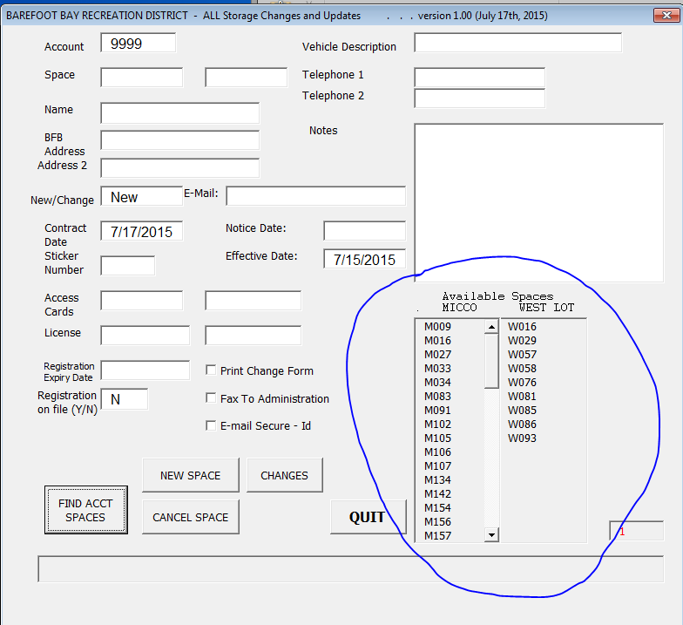

d) At the bottom of the screen is the message area. This will tell you if your actions have been completed successfully or if further action will be needed to complete your transaction. 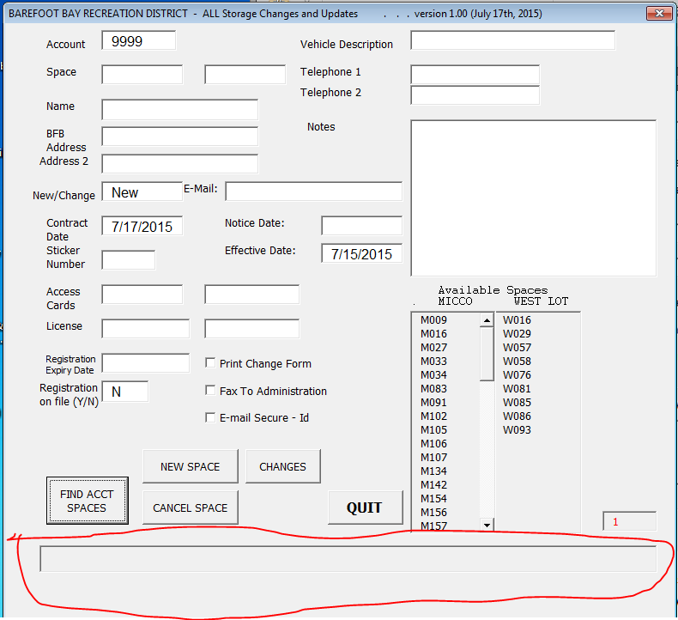

e) The fields are mostly self-explanatory. You are allowed to enter and process TWO Spaces, TWO Access Cards, TWO License numbers and TWO telephone numbers.

1) The Notice Date documents when a resident has given “notice to cancel” on their RV spot. This is usually 10 days.

2) The Effective Date refers to when the paper “Change Notice” sheet was filled in and signed by the resident. The process of putting RV information into the computer might be different than the actual transaction date with the resident. This difference should be documented.

3) The Print to Change Form and Fax to Administration check boxes will probably be gone. They are future functions that were never implemented.

4) E-mail Secure – Id – Check this if you are activating or de-activating a secure-id card. This will generate an automatic email to ADS giving them instructions. Outlook needs to be open for this to function correctly. This will bring up the window, but the operator needs to hit the send button to have the e-mail delivered. This insures the user double checks the information and give the opportunity to add or removed items from the email. Also, the body of the message will change, depending on the function ( New Space, Cancel, replace secure – id card) selected.

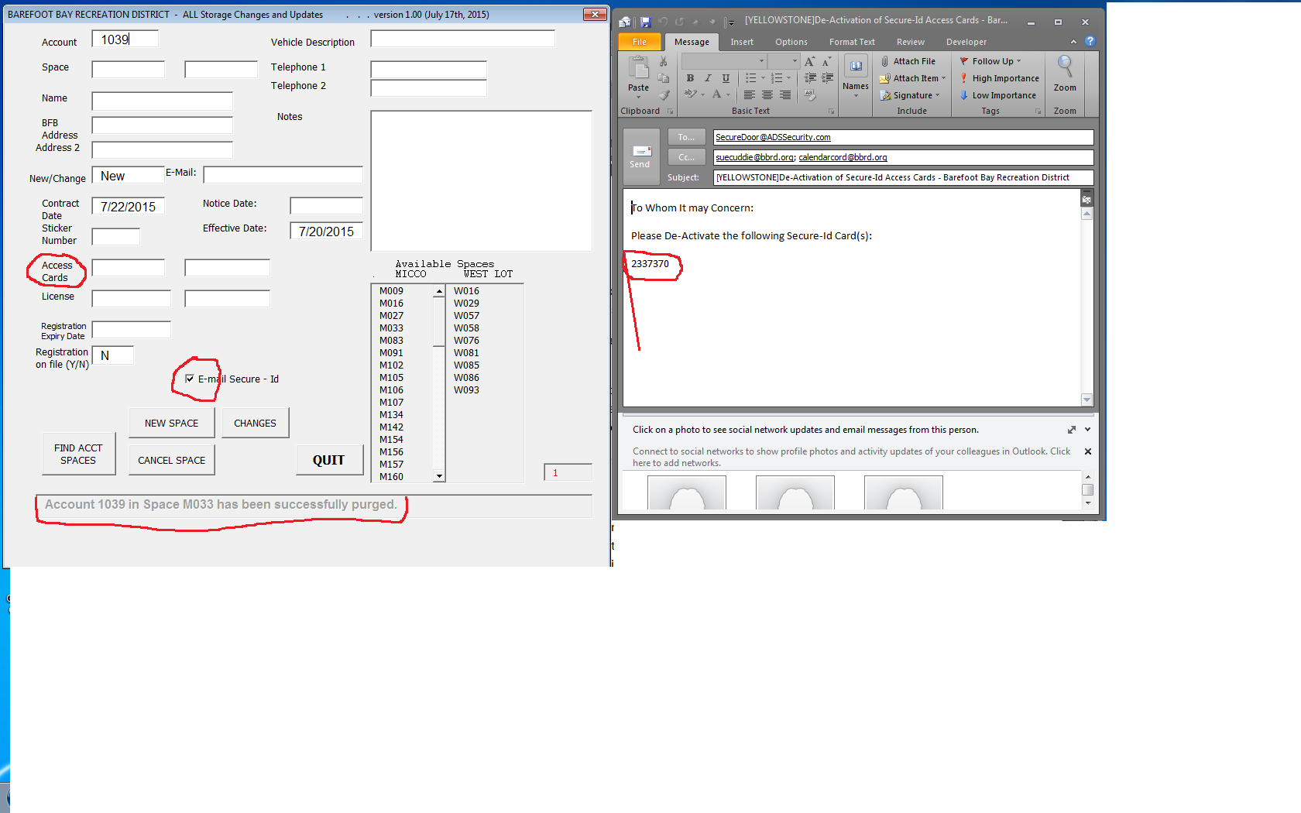

f) One important note is NO items are saved. Before exiting the spreadsheet, you must SAVE your work!

g) The original spreadsheet is always available by pressing the “QUIT” button on the lower right of the button group. There are a number of spreadsheet tabs but only the first three are of any major importance.

1. The first one is called “Space #”. This is the main and most important database of the entire workbook. The base information is here.
2. The second is called “by Name”. This is basically a copy of the first worksheet but sorted by Last Name and Space number. The receptionists use this report and they ask for it on a monthly basis. This spreadsheet can be re-created as needed by clicking the little printer icon .Please deleted the “by_Name” spreadsheet before recreating it( by clicking the printer icon ).
3. The third is called “Historical tracking”. This spreadsheet is very much related to the first. It’s basically a transaction log of the comings and goings of both Barefoot Bay Recreation Districts RV Lots. The main column, or “key”, is the “Sticker Number”.
4. There are three additional spreadsheets. These are used by Sue Cuddie. Refer to her for additional explanation on these three spreadsheets.
5. There might be instances when manual updates are necessary. This is allowed. The “by_Name” and “Historical tracking” can be changed freely. The first spreadsheet, the “Space #” , some fields may be changed, others are password protected. The password is located in Cell “AG2”. As of July 31st, the password is “RV” in all capital letters. Please do NOT change the names of the spreadsheet. Also, leave some password, “RV” or whatever… , in cell “AG2” since the programming code looks for these specific tab names and for the password in location cell “AG2” ! Also note, that the button that brings up the screen is also near, In cell “AB9”.

